
Technical Submittal – R 02
Oct 2020
Prepared for Endress + Hauser, Waluj Aurangabad

Dock Shelter, Scissor Lift, Motorized Rolling Shutter, Manual Wicket Gate, Double Sided Flap Gate:

Contactor Name:
Shubhshree Engineering and Constructions Pvt Ltd
401-404, Sai Business centre, Osmanpura
Aurangabad-431005, MH, India.

Supplied Name: NIHVA Technologies Pvt Ltd

Prepared by,
Shubhshree Engineering and Constructions Pvt Ltd
401-404, Sai Business centre, Osmanpura
Aurangabad-431005, MH, India.

Table of Contents

- Introduction
- Product Sample Photo
- Scope of Supply
- BOQ & Compliance
- GA Drawing
- Technical submittals
- Factory sample test reports
- Optional Items & Deviation List

- Introduction

NIHVA Technologies Pvt Ltd, Pune

NIHVA’s Head Office & manufacturing facility is located in Pune in Maharashtra (India) & sales office at various metro cities.
NIHVA is young and growing company, having experience of 7 years in industrial market. NIHVA specializes in providing integrated solutions in Door Automation & Automation Solutions.
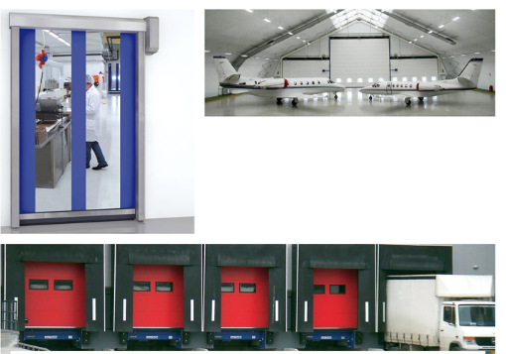

Apart from this NIHVA is also equipped in providing water management and drainage solutions (external and internal).

- Product Sample Photos

Scissor Lift
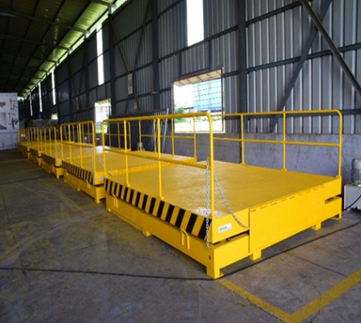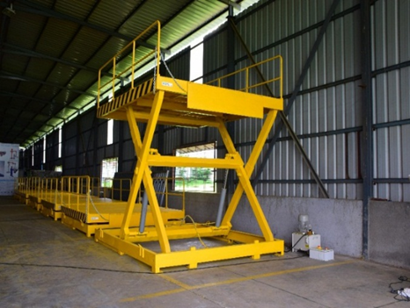
Retractable Dock Shelters
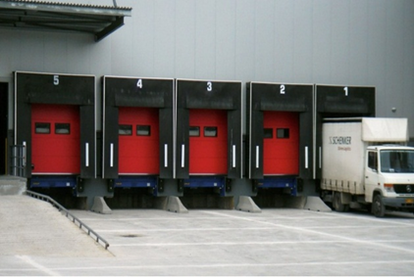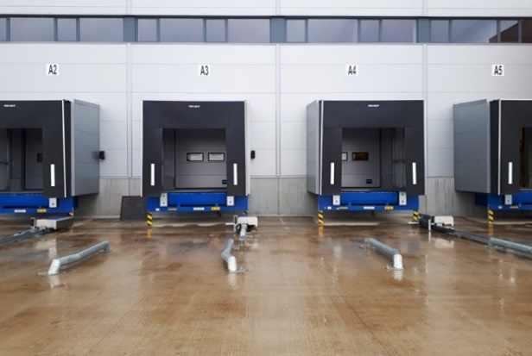

Motorised two leaf Telescopic Gate
Manual Wicket Gate

Double Sided Flap Gate:

- Scope of Supply
Sr. N | Products | Size | Qty | Remark
1 | Hot Dip Galvanized Scissor Lift | (W) 2000 mm X (L) 2500 mm | 4 | Size As per BOQ
2 | Retractable Dock Shelter | (W) 3450 mm X (L) 3400 mm | 4 | Size As per BOQ
3 | Rolling Shutter | (W) 2500 mm X (L) 4000 mm  (W) 4000 mm X (L) 4000 mm | 4  8 | Size As per BOQ  Size As per BOQ
4 | Telescopic Sliding Gate | (W) 6000 mm X (L) 1800 mm | 1 | Size of gate to be conform
5 | Wicket Gate | (W) 1200 mm X (L) 1800 mm | 1 | Size of gate to be conform
6 | Double leaf SS Flap Barrier Gate | 1400 x 280 x 980 mm | 1 | Size of gate to be conform

- BOQ & Compliance

- GA Drawing

Actual GA Drawing shall be provide after confirmation of PO

Scissor Lift GA Drawing Option - 1
We suggest to keep on ground as it will not give mobile movement and will be stationary which will increase the life of Scissor lift.

Scissor Lift GA Drawing Option - 2

Telescopic Sliding Gate

- Technical submittals

Scissor Lift:
Sr. NO | Description | Specification
1 | Capacity | 6 Ton (UDL)
2 | Platform Size | (W) 2000 mm X (L) 2500 mm
3 | Shut Ht | 1000 mm
4 | Max Ht | 2200 mm
5 | Lift Ht | 1200 mm
6 | Safety Railing | Safety railing M.S SECTION 900 mm ht all side on platform & fixed
7 | Manual Lip | 3 Piece (240 + 1500 + 240) - 1 Side Only
8 | Maintenance Stopper | 2 NOS
9 | Push Button Pendent | Flexible pendent with 5 mtr Cable - 1 No
10 | Control Panel | Outside pit - 1 No
11 | Safety Bellow | All side
12 | Power Pack Inside Pit with Buzzer | 15 HP, 3 Phase - Eaton make
13 | Hydraulic Cylinder | Two numbers with Bore 150 X stroke 500 mm - Eaton make
14 | Hot Dip Galvanized | IS 2629 / EN ISO 1461 / As per ASTM
15 | Hose | Parker Hoses
16 | Cable | Polycab cables
17 | Hydraulic Oil | Grade 68 - 125 Ltr
18 | Paint | Gloosy-20Ltr
19 | Fabrication | 3500KG

Dock Shelter:
SR NO | Description | Specification
1 | Size | (W) 3450 mm x (H) 3400 mm
2 | Curtain Color | Black
3 | Parking Guides | White, Yellow
4 | Wall Fixings | Concrete, Sandwich light Concrete, Load house cavity, insulated panel
5 | Top & Side Curtains | Double Layer High Quality Polyester
6 | Thickness | 3.0 mm
7 | Weight | Approx. 3400 g/m2
8 | Continuous Roof Cover | One layer high quality Polyester
9 | Thickness | 0.5 mm
10 | Front White Patch | Reflective strips

ASSA ABLOY DS6060A Curtain dock shelter aluminium
Product description:
DS6060A Curtain dock shelter aluminium
• Frame in extruded aluminium sections
• Front and rear frame spring-loaded and connected with parallel bracing arms
• Roof construction rises automatically as truck approaches
• Continuous wall and roof cover
• Easily replaceable curtains
• Curtain quality
• Top curtain /side curtains:
• Double-layered high quality polyester, coated on both sides
• Total weight approx. 3400g/m²
• Flammability (DIN 75200)
• Tensile strength: DIN 53354
Longitudinal strength: approx. 7000N/5cm transverse strength: approx. 5000N/5cm
• Tear elongation: DIN 53363
Longitudinal strength: approx. 750N transverse strength: approx. 900N
• Continuous roof cover
• One layer high quality polyester, coated on both sides
• Total weight approx. 600g/m²
• Flammability (DIN 75200)
• Tensile strength: DIN 53354
Longitudinal strength: approx. 2500N/5cm transverse strength: approx. 2600N/5cm
• Tear elongation: DIN 53363
Longitudinal strength: approx. 250N transverse strength: approx. 250N
• Top curtain with a slit in the main wear area to minimize contact pressure from the truck
• Installation height 4500 mm above outside yard level
• Standard variants
Nominal height 3200, 3400, 3600mm
Nominal width 3250, 3450mm

• Top curtain:
□ Top curtain 1000mm
□ Splitted top curtain 1000mm (4 slits in the wear area)
□ Top curtain 1200mm
□ Splitted top curtain 1200mm (4 slits in the wear area)

• Nominal depth:
□ Nominal depth 600mm
□ Nominal depth 900mm
• Side curtain:
□ Side curtain 600mm (Nominal width 3250mm)
□ Side curtain 700mm (Nominal width 3450mm)

• Color:
□ black 
□ blue (RAL 5010, side and front curtains)
• Color of parking guides
□ white
□ yellow (sim. to RAL 1023)
Wall fixings:
□ Concrete 
□ Sandwich 
□ ISO panel wall
□ Light concrete
□ Loadhouse
Dimensions:
mm | Nominal height | 3200, 3400, 3600mm
mm | Nominal width | 3250, 3450mm
Options:
□ Digit on top curtain (Height 300mm)
□ Roof part with integrated rain channel
□ Reinforced rubber flaps in the side curtain
□ Notching on both sides
□ Corner seals to prevent draft in lower area ESR, ES 600, ES 900

Motorised Rolling Shutter:

Sliding Gate:

Sr. No | Description | Specification
1 | Door type | Motorized Two Leaf Telescopic Sliding Gate
2 | Size considered | Clear opening - (W) 6000 mm x (H)1800 mm
3 | Opening Direction | Horizontal - from left to right or reverse
4 | Mounting Location area | Inside area
5 | Design Pattern | Standard Tubular Design Pattern
6 | Outer Frame Tube Sizes | 80 x 80 x 3.2 mm
7 | Internal Vertical Tube Sizes | 40 x 40 x 2 mm
8 | Gap Between Tubes | 100 mm C/C
9 | Bottom Rail on ground | dia 20 mm round bright bar with heavy duty support ISMB 100 X 50 Beams
10 | Bottom Rollers | Heavy Duty Bottom Wheel With both side Bearings (chrome plated)
11 | Guide Rollers supporter during Gate movement | Nylon Rollers with Bearings both side mounted on column for support smooth movement of gate
12 | Painting | 2 Coats of EPOXY polyamide based enamel finish of approved Colour
13 | El motor make | BFT – Italy (100% imported)
14 | Operating Switch | Push Button from inside
15 | Operation | By Telescopic Mechanism
16 | Safety | Photocells, Flashing Light

Wicket Gate:

Sr. No | Description | Specification
1 | Door type | Manual Single Leaf Wicket Gate
2 | Size considered | Clear opening - (W)1200 mm x (H)1800 mm
3 | Mounting Location area | Inside area
4 | Design Pattern | Standard Tubular Design Pattern
5 | Outer Frame Tube Sizes | 80 x 80 x 3.2 mm
6 | Internal Vertical Tube Sizes | 40 x 40 x 2 mm
7 | Gap Between Tubes | 100 mm C/C
8 | Painting | 2 Coats of EPOXY polyamide based enamel finish of approved Colour
9 | Operation | Manually Opening

Double Leaf SS Flap Barrier Gate:

Sr. No | Description
1 | It has zero position of self -checking, easy for users to maintain and use.
2 | There is alarm notice function when illegal access.
3 | Avoid bump function: When the turnstile does not receive the open signals, the baffle will lock automatically.
4 | IR/mechanical dual anti-lined function: When the baffle has problem in reseeding, it will stop working automatically in certain time, and the potency is small, will make an alarm sound at the same time.
5 | Resent automatically: the passenger read effectively, the system will cancel this access authority if they will not access in certain time.
6 | Standard wiring connection: can connect with many kinds of card readers, and can remote control through the computer.
7 | High throughput, Bi-directional control, Open / Close light indication
8 | Optical beams for safety movements, Ensures rapid, efficient & safe access control
9 | Easily integrated into access control system, Automatic reset of barrier flap after each valid entry, mechanical release key for emergency cases, fire trigger input facility. In the event of power failure panels can be specified to remain closed
10 | The whole system works steadily, and the noise is very low. Size: 1400 x 280 x 980mm; Unlock time: 0.2s Pass rate: 35 person/min; Pass Width: ≤550mm; Input:  100V~240V; Driving Voltage: 24v; Environment: -25~70°c; Power Consumption: 35w; Input: 12v dry contact.

- Factory Sample Test Report

Shall be provided along with Product

- Optional Items & Deviation List

S. N | Description | Remarks
1 | NIHVA Hot Dip Galvanized Scissor Lift  (W) 2000 mm X (L) 2500 mm | Complied With BOQ
2 | NIHVA ASSA ABLOY Retractable Dock Shelter  Articulated Galvanized steel zinced retractable structure  BOQ: (W) 3450 mm X (L) 3600 mm  front opening width : 2140mm + 630 side flaps on both sides | Aluminium Structure  NIHVA (W) 3450 mm X (L) 3400 mm  front opening width: 2050mm + 700 side flaps on both sides
3 | Any civil / masonry/structural work required | Not in Scope
4 | All structure support | Shall be provided with additional cost.
5 | In Case of any changes in the layout as per site requirements after the shipment of material, the additional quantities and the wastage. | Not in Scope
6 | Conduits, Cables required | Not in Scope
7 | Safety Railings in Scissor Lift | Along Length sides only

SR NO | Product | Remarks
8 | Flap Barrier | Required in SS material
8 | Flap Barrier | Double leaf Type
8 | Flap Barrier | Need to be integrated with clients RFID card
8 | Flap Barrier | Client will provide RFID tag with receiver
8 | Flap Barrier | Detail Technical specs to be provided by client (BOQ)
9 | Sliding Gate | Client has considered rectrable sliding gate but after detailed technical discussion NIHVA has proposed Telescopic Sliding Gate
9 | Sliding Gate | Sliding gate needs to Hot dip galvanized
9 | Sliding Gate | Client will provide detail dimension along with single leaf or double leaft type & required accessories
9 | Sliding Gate | Make: NIHVA
10 | Rolling Shutter | Electric Motor need to be consider Direct Drive
10 | Rolling Shutter | Curtain Profile need to be considered curved type & perforated type
10 | Rolling Shutter | Rolling shutter need to be powder coated (RAL 9006)
 |  |  |  | Hot Dip Galvanized
12 | Scissor Lift | All platform four edges should have safety edge
12 | Scissor Lift | Safety Below need to be consider
12 | Scissor Lift | Interlock with Dock Leveler & Sectional Door
12 | Scissor Lift | Make : NIHVA
12 | Scissor Lift | Make : NIHVA
 | Product | Make as per BOQ | Revised make
13.1 | Scissor Lift | NIHVA make | Revised: Safety Edge & bellows added
13.2 | Retractable Dock Shelter | NIHVA make | ASSA ABLOY (Crawford)  Revised: front patch should be reflective white strips
13.3 | Motorised Rolling Shutter | Make: NIHVA  Single skinned GI Rolling Shutter  Profile - Curved  Indirect Drive Motor : PRC Make | Make: Option 1 : NIHVA  Single skinned Galvalume Rolling Shutter  Direct Drive Motor : German Make  Profile: Flat

